Name

Mathematics Extension 1 Year 12
Sum and Product of Zeroes

Book 1 |  | Version: 261007  Feedback:  https://MrDingMaths.com
Contents
Syllabus Content 2
Learning Intention 3

Syllabus Content
ME1-11-02 applies the remainder and factor theorem and sums and products of zeroes to solve problems involving polynomials
Sums and products of zeroes of polynomials
- Prove that if a quadratic $P\left(x\right)=ax^{2}+bx+c$ has zeroes $α$ and $β$ then $α+β=-\frac{b}{a}$, the sum of the zeroes, and $αβ=\frac{c}{a}$, the product of the zeroes
- Prove that if a cubic $P\left(x\right)=ax^{3}+bx^{2}+cx+d$ has three zeroes $α$, $β$, $γ$, then $α+β+γ=-\frac{b}{a}$, $αβ+βγ+γα=\frac{c}{a}$ and $αβγ=-\frac{d}{a}$
- Prove that if a quartic $P\left(x\right)=ax^{4}+bx^{3}+cx^{2}+dx+e$ has four zeroes $α$, $β$, $γ$, $δ$ then $α+β+γ+δ=-\frac{b}{a}$, $αβ+αγ+αδ+βγ+βδ+γα=\frac{c}{a}$, $αβγ+βγδ+γδα+δαβ=-\frac{d}{a}$ and $αβγδ=\frac{e}{a}$
- Use the formulas for the sums and products of zeroes to solve problems involving zeroes and coefficients of quadratic, cubic and quartic polynomials

Sum and Product of Roots (Quadratic)

- Sum and Product of Zeroes for a Quadratic Equation
Consider this polynomial.
$$P(x)=(x-2)(x-3)(x-5)(x-7)=x^{4}-17x^{3}+101x^{2}-247x+210$$

The coefficients of the expanded polynomial are: $1$, $-17$, $101$, $-247$, $210$
These must come from $2, 3, 5, 7$. But can we get them quickly without expanding?

Try adding all the numbers: $2+3+5+7=$ ………

Try multiplying all the numbers: $2\left(3\right)\left(5\right)\left(7\right)=$ ………

If we can find a formula relating the coefficients and the zeroes, we can factorise and expand polynomials very quickly.

Let’s start with a quadratic function $f\left(x\right)=ax^{2}+bx+c$,

The zeroes, or roots, of the function are when $f\left(x\right)=$ ………
This corresponds to the ……-intercepts of the function.

To find the zeroes, we can use the quadratic formula:

$$x=\frac{-b±\sqrt{b^{2}-4ac}}{2a}$$

The sum of the zeroes will be: | The product of the zeroes will be:
Alternate proof
Let $ax^{2}+bx+c=0$, we can make this polynomial monic by $x^{2}+\frac{b}{a}x+\frac{c}{a}=0$
suppose it can be factorised to $P\left(x\right)=\left(x-α\right)\left(x-β\right).$
By expanding $P\left(x\right)=\left(x-α\right)\left(x-β\right)$, equate coefficients to determine $α+β$ and $αβ$.

- Sum and Product of Zeroes (Quadratic)
For a quadratic $P\left(x\right)=ax^{2}+bx+c$ with zeroes (roots) $α$ and $β$:
$$α+β=-\frac{b}{a} \\ αβ=\frac{c}{a}$$

- Sum and Product of Zeroes for Quadratics
By factorising, test that the sum and product of zeroes formula work for these quadratic functions.
- $P\left(x\right)=x^{2}+7x+10$  $$P\left(x\right)=( )( )$$  $$α+β=$$  $$αβ=$$ | - $P\left(x\right)=x^{2}+3x-10$
- $P\left(x\right)=3x^{2}+21x+30$ | - $P\left(x\right)=2x^{2}+5x-12$

- Example Apply sum and product of zeroes formulas for quadratics
Worked Example | Your Turn
If $α$ and $β$ are the roots of $2x^{2}-6x+1=0$, find:  $α+β$ $=-$ $\frac{b}{a}$ $=-$ $\frac{-6}{2}$  $=3$  $αβ$ $=$ $\frac{c}{a}$  $=$ $\frac{1}{2}$  $α^{2}+β^{2}$  using ${\left(α+β\right)}^{2}=α^{2}+2αβ+β^{2}$  $${\left(α+β\right)}^{2}-2αβ=α^{2}+β^{2}$$  $$α^{2}+β^{2}={\left(3\right)}^{2}-2\left(\frac{1}{2}\right)$$  $$=8$$ | If $α$ and $β$ are the roots of $2x^{2}+3x+5=0$, find:  $$α+β$$  $$-\frac{3}{2}$$  $$αβ$$  $$\frac{5}{2}$$  $α^{2}+β^{2}$  $$\frac{25}{4}$$
- Sum of Squares Identity
This identity is helpful in solving problems involving sum and product of zeroes:
$$α^{2}+β^{2}={\left(α+β\right)}^{2}-2αβ$$

- Example Apply sum and product of zeroes formulas for quadratics
Worked Example | Your Turn
Show that $x=3$ is a zero of  $P(x)=2x²-9x+9$,  Hence find the other zero.  $$P\left(3\right)=2{\left(3\right)}^{2}-9\left(3\right)+9=0$$  Using $α+β=-$ $\frac{b}{a}$  $$3+β=\frac{9}{2}$$  $$β=\frac{3}{2}$$ | Show that $x=-2$ is a zero of  $P(x)=3x²+5x-2$,  Hence find the other zero.  $$\frac{1}{3}$$
Find $p$ if one root of $x^{2}+2x-5p=0$ is double the other root.  Let roots be $α$ and $2α$.  Sum of roots:  $$α+2α=-2$$  $$3α=-2$$  $$α=-\frac{2}{3}$$  $$∴roots are-\frac{2}{3} and-\frac{4}{3}$$  Product of roots:  $$α\left(2α\right)=-5p$$  $$2α^{2}=-5p$$  $$p=-\frac{2α^{2}}{5}$$  $$=\frac{-2{\left(-\frac{2}{3}\right)}^{2}}{5}$$  $$=-\frac{8}{45}$$ | Find $q$ if one root of $x²-4x+q=0$ is triple the other root.  $$q=3$$

Foundation
- Let $α$ and $β$ are the roots of the given quadratic equation.
For each equation, find:
- $x^{2}+2x+8=0$ | - $3x^{2}-6x-2=0$
  $α+β$  2 | $αβ$  8
  $α+β$  $$-2$$ | $αβ$  $$-\frac{2}{3}$$
- $4x^{2}-9x-12=0$ | - $5x^{2}+15x=0$
  $α+β$  $$\frac{9}{4}$$ | $αβ$  $$-3$$
  $α+β$  $$-3$$ | $αβ$  0

- The equation of a monic quadratic polynomial with roots $α$ and $β$ is:
$$x^{2}-\left(α+β\right)x+αβ=0$$
Use this to find the quadratic equation, with integer coefficients, whose roots are:
- $±5$  $$x^{2}-25=0$$ | - $3$ and $-5$  $$x^{2}+2x-15=0$$ | - $2±\sqrt{3}$  $$x^{2}-4x+1=0$$ | - $\frac{2}{5}$ and $\frac{5}{2}$  $$10x^{2}-29x+10=0$$

- Let the roots of $4x^{2}-5x-1=0$ be $α$ and $β$. Find the value of the following, without explicitly solving for $α$ and $β$.
- $α+β$  $$\frac{5}{4}$$ | - $αβ$  $$-\frac{1}{4}$$ | - $\frac{1}{α}$ $+$ $\frac{1}{β}$  $$-5$$
- $\left(α-3\right)\left(β-3\right)$  $$5$$ | - $α^{2}+β^{2}+2αβ$  $$\frac{25}{16}$$ | - $α^{2}β+β^{2}α$  $$-\frac{5}{16}$$

  - Expand ${\left(α+β\right)}^{2}$

$$α^{2}+2αβ+β^{2}$$
  - Hence, express $α^{2}+β^{2}$ in terms of $\left(α+β\right)$ and $αβ$.

$$α^{2}+β^{2}={\left(α+β\right)}^{2}-2αβ$$
  - Let the roots of $x^{2}-3x-2=0$ be $α$ and $β$. Find the value of $α^{2}+β^{2}$

$$13$$
- Let $α$ and $β$ be the roots of $x^{2}-4x+2=0$. Find:
- $α+β$  4 | - $αβ$  2 | - $α^{2}β+αβ^{2}$  8
- $\frac{1}{α}$ $+$ $\frac{1}{β}$  2 | - $\left(α+2\right)\left(β+2\right)$  14 | - $α^{2}+β^{2}$  12
- $\frac{α}{β}$ $+$ $\frac{β}{α}$  6 | - $αβ^{3}+α^{3}β$  24 | - $\left(α+\frac{1}{α}\right)\left(β+\frac{1}{β}\right)$  $$\frac{17}{2}$$

- Suppose that the quadratic equation $x^{2}-kx-4x-35=0$ has the sum of roots being 2.
Find the value of $k$.

$$k=-2$$

Development
- If $α$ and $β$ are the zeroes of $2x^{2}+5x-4=0$, find:
- $α+β$  $$-\frac{5}{2}$$ | - $αβ$  $$-2$$ | - $α^{2}+β^{2}$  $$\frac{41}{4}$$ | - $\left|α-β\right|$(hint: square it)  $$\frac{\sqrt{57}}{2}$$

- One zero of $x^{2}-3x+k-2=0$ is $-4$. Find the value of $k$.
$-4+β=3$, $∴β=7$
$-4β=k-2$,
$-28=k-2$, $∴k=-26$
Alternate method:
$$P\left(-4\right)=16+12+k-2=0$$
$$k=-26$$

- Find the value(s) of $k$ if the quadratic equation $x^{2}-\left(k+2\right)x+k+1=0$ has:
- Equal roots  $$k=0$$ | - One root equal to 5  $$k=4$$
- Consecutive roots  $$k=±1$$ | - One root double the other  $$k=-\frac{1}{2}, 1$$
- Reciprocal roots

$$k=0$$

- Let $3-\sqrt{2}$ be a root of the quadratic equation $x^{2}+mx+7=0$, where $m$ is a rational number.
Find the
- other root  $$3+\sqrt{2}$$ | - value of $m$  $$-6$$

  - Suppose the quadratic equation $4x^{2}-px-5=0$ has two roots that are of equal magnitude but opposite in sign. Find the value of $p$.
Let roots be $α, -α$
Sum of roots:$α+\left(-α\right)=-$ $\frac{b}{a}$
$$0=-\frac{p}{4}$$
$$p=0$$
  - Suppose the quadratic equation $x^{2}+5x+3p-1=0$ has two roots that are reciprocals of each other. Find the value of $p$.
Let roots be $α,$ $\frac{1}{α}$
Product of roots: $α×$ $\frac{1}{α}$ $=$ $\frac{c}{a}$
$$1=3p-1$$
$$p=\frac{2}{3}$$
- If one of the roots of $x^{2}+bx+c=0$ is twice the other root, show that $2b^{2}=9c$.
Let roots be $α, 2α$
Sum of roots: $3α=-b$ (1)
Product of roots: $2α^{2}=c$ (2)
Rearrange (1): $α=-$ $\frac{b}{3}$, Sub into (2)
$$2{\left(-\frac{b}{3}\right)}^{2}=c$$
$\frac{2b^{2}}{9}$ $=c$
$2b^{2}=9c$
- If the roots of the equation $x^{2}+px+q=0$ are consecutive numbers,
show that $p^{2}=4q+1$.
Let roots be $α,α+1$
Sum of roots: $2α+1=-p$ (1)
Product of roots: $α^{2}+α=q$ (2)
Rearrange (1): $α=$ $\frac{-p-1}{2}$, Sub into (2)
$${\left(\frac{-p-1}{2}\right)}^{2}+\frac{-p-1}{2}=q$$
$$\frac{p^{2}+2p+1}{4}+\frac{-2p-2}{4}=q$$
$$p^{2}-1=4q$$
$$p^{2}=4q+1$$
- One root of $x^{2}+px+q=0$ is three times the other. Show that $3p^{2}=16q$.
Let roots be $α, 3α$
Sum of roots $4α=-p$ (1)
Product of roots $3α^{2}=q$ (2)
Rearrange (1): $α=-$ $\frac{p}{4}$, Sub into (2)
$$3{\left(-\frac{p}{4}\right)}^{2}=q$$
$$\frac{3p^{2}}{16}=q$$
$$3p^{2}=16q$$

Mastery
- Let the roots of $x^{2}-3x+10=0$ be $α$ and $β$.
Find the equation of the quadratic with roots $α+2$ and $β+2$.
$α+β=3$, $αβ=10$
Let new quadratic be $x^{2}+\frac{b}{a}x+\frac{c}{a}=0$
Sum of roots $\left(α+2\right)+\left(β+2\right)=-$ $\frac{b}{a}$
$$α+β+2=-\frac{b}{a}$$
$$7=-\frac{b}{a}$$
Product of roots: $\left(α+2\right)\left(β+2\right)=$ $\frac{c}{a}$
$$αβ+2(α+β)+4=\frac{c}{a}$$
$$10+2\left(3\right)+4=\frac{c}{a}$$
$$20=\frac{c}{a}$$
$$∴x^{2}-7x+20=0$$
- If $α$ and $β$ are the roots of $5x^{2}+mx-5=0$, find the exact value of $\left(5α+m\right)\left(5β+m\right)$
$$α+β=-\frac{m}{5}, αβ=-1$$
$$\left(5α+m\right)\left(5β+m\right)$$
$$=25αβ+5αm+5βm+m^{2}$$
$$=25αβ+5m\left(α+β\right)+m^{2}$$
$$=25\left(-1\right)+5m\left(-\frac{m}{5}\right)+m^{2}$$
$$=-25-m^{2}+m^{2}$$
$$=-25$$
- Let $α$ and $β$ be the roots of $x^{2}-x+4=0$.
  - Find the value of $α^{2}+β^{2}$.
$$α^{2}+β^{2}={\left(α+β\right)}^{2}-2αβ$$
$=1-2\left(4\right)$
$=-7$
  - Hence explain why the roots of this quadratic are not real.

The sum of two squares is negative. This is not possible with real numbers.
- Let $α$ and $β$ be the roots of $2x^{2}-8x+1=0$. Find the quadratic equation whose roots are:
- $\frac{1}{α}$ and $\frac{1}{β}$  $$α+β=4, αβ=\frac{1}{2}$$  Let new quadratic be $x^{2}+\frac{b}{a}x+\frac{c}{a}=0$  $$\frac{1}{α}+\frac{1}{β}=-\frac{b}{a}$$  $$\frac{β+α}{αβ}=-\frac{b}{a}$$  $$8=-\frac{b}{a}$$  $$\frac{1}{αβ}=\frac{c}{a}$$  $$2=\frac{c}{a}$$  $$x^{2}-8x+2=0$$ | - $α^{2}$ and $β^{2}$  $$α+β=4, αβ=\frac{1}{2}$$  Let new quadratic be $x^{2}+\frac{b}{a}x+\frac{c}{a}=0$  $$α^{2}+β^{2}=-\frac{b}{a}$$  $${\left(α+β\right)}^{2}-2αβ=-\frac{b}{a}$$  $$4^{2}-1=-\frac{b}{a}$$  $$15=-\frac{b}{a}$$  $$α^{2}β^{2}=\frac{c}{a}$$  $$\frac{1}{4}=\frac{c}{a}$$  $$x^{2}-15c+\frac{1}{4}=0$$  $$∴4x^{2}-60x+1=0$$

Sum and Product of Roots (Cubic)

- Sum and Product of Zeroes for a Quadratic Equation
Let $ax^{3}+bx^{2}+cx+d=0$, we can make this polynomial monic by $x^{3}+\frac{b}{a}x^{2}+\frac{c}{a}x+\frac{d}{a}=0$
suppose it can be factorised to $P\left(x\right)=\left(x-α\right)\left(x-β\right)\left(x-γ\right).$
By expanding $P\left(x\right)=\left(x-α\right)\left(x-β\right)\left(x-γ\right)$, equate coefficients to determine the relationship between zeroes and coefficients.

- Sum and Product of Zeroes (Quadratic)
For a cubic $P\left(x\right)=ax^{3}+bx^{2}+cx+d$ with zeroes $α, β, γ$:
$$α+β=-\frac{b}{a} \\ αβ+αγ+βγ=\frac{c}{a} \\ αβγ=-\frac{d}{a}$$

- Describe $αβ+αγ+βγ$ as ‘sum of products taken two at a time’

- Sum of Squares Identity (3 zeroes)
$$α^{2}+β^{2}+γ^{2}={\left(α+β+γ\right)}^{2}-2\left(αβ+αγ+βγ\right)$$

- Example Apply sum and product of zeroes formulas for cubics
$α, β,γ$ are the roots of $2x^{3}-5x^{2}+x-1=0$, Find:
$${\left(α+β+γ\right)}^{2}$$  $$α+β+γ=-\frac{b}{a}=\frac{5}{2}$$  $${\left(α+β+γ\right)}^{2}={\left(\frac{5}{2}\right)}^{2}$$  $$=\frac{25}{4}$$ | $$\left(α+1\right)\left(β+1\right)\left(γ+1\right)$$  $$=\left(α+1\right)\left(βγ+β+γ+1\right)$$  $$=αβγ+αβ+αγ+α+βγ+β+γ+1$$  $$=αβγ+(αβ+αγ+βγ)+(α+β+γ)+1$$  $$=-\frac{d}{a}+\frac{c}{a}+\left(-\frac{b}{a}\right)+1$$  $$=\frac{1}{2}+\frac{1}{2}+\frac{5}{2}+1$$  $$=\frac{9}{2}$$

- Guided Practice
$α, β$ and $γ$ be the roots of $x^{3}-3x+2=0$. Find:
- ${\left(α+β+γ\right)}^{2}$ | - $\left(α+1\right)\left(β+1\right)\left(γ+1\right)$
- $\frac{1}{α}+\frac{1}{β}+\frac{1}{γ}$ | - $\frac{1}{αβ}+\frac{1}{αγ}+\frac{1}{βγ}$
- $α^{2}β^{2}γ+α^{2}γ^{2}β+β^{2}γ^{2}α$ | - $α^{2}+β^{2}+γ^{2}$

- Proofs involving Sum and Product of Roots
Harder questions require you to prove general statements about polynomials.
There is no step-by-step procedure for these questions, but it is helpful to:
- Clearly define the roots using the restrictions.
- Begin by writing out the sums and products of roots formulas.
- Use the sum equations and product equations first, as they are most simple.
- Use simultaneous equations to show the required statement.
- It is often easier if you do not find expressions for individual roots.

- Guided Practice
- If one zero of the cubic $f\left(x\right)=ax^{3}+bx^{2}+cx+d$ is the opposite of the other, prove that $ad=bc$.

- If two of the roots of the equation $x^{3}+qx+r=0$ are equal, show that $4q^{3}+27r^{2}=0$.

Foundation
- Where $α, β$, $γ$ are roots of the equation, for each cubic find:
- $x^{3}+x^{2}-2x+8=0$ | - $2x^{3}-x^{2}+6x+2=0$
  $α+β+γ$  $$-1$$ | $αβ+αγ+βγ$  $$-2$$ | $αβγ$  $$-8$$
  $α+β+γ$  $$\frac{1}{2}$$ | $αβ+αγ+βγ$  $$3$$ | $αβγ$  $$-1$$
- $-x^{3}-3x^{2}-11=0$ | - $x^{3}+7x-3=0$
  $α+β+γ$  $$-3$$ | $αβ+αγ+βγ$  0 | $αβγ$  $$-11$$
  $α+β+γ$  $$0$$ | $αβ+αγ+βγ$  $$7$$ | $αβγ$  $$3$$

- If $α, β$, and $γ$ are the roots of $2x^{3}+5x^{2}-x-3=0$, find:
- $αβγ$  $$\frac{3}{2}$$ | - $αβ+αγ+βγ$  $$-\frac{1}{2}$$ | - $α+β+γ$  $$-\frac{5}{2}$$
- $\frac{1}{α}$ $+$ $\frac{1}{β}$ $+$ $\frac{1}{γ}$  $$-\frac{1}{3}$$ | - $\left(α+1\right)\left(β+1\right)\left(γ+1\right)$  $$-\frac{1}{2}$$

- If $α, β$, and $γ$ are the roots of $x^{3}+2x^{2}-11x-12=0$, find:
- $α+β+γ$  $$-2$$ | - $αβ+αγ+βγ$  $$-11$$ | - $αβγ$  $$12$$
- $\frac{1}{α}$ $+$ $\frac{1}{β}$ $+$ $\frac{1}{γ}$  $$-\frac{11}{12}$$ | - $\frac{1}{αβ}$ $+$ $\frac{1}{αγ}$ $+$ $\frac{1}{βγ}$  $$-\frac{1}{6}$$ | - $\left(α+1\right)\left(β+1\right)\left(γ+1\right)$  0
- $α^{2}β^{2}γ+α^{2}γ^{2}β+β^{2}γ^{2}α$  $$-132$$ | - $α^{2}+β^{2}+γ^{2}$  $$26$$ | - ${\left(αβ\right)}^{-2}+{\left(αγ\right)}^{-2}+{\left(βγ\right)}^{-2}$  $$\frac{13}{72}$$

- If two roots of the cubic equation $x^{3}+ax^{2}+bx+24=0$ are 4 and $-2$.
Find the values of $a$ and $b$ and hence state equation of the cubic.
Product of roots: $\left(4\right)\left(-2\right)γ=-24$
$$γ=3$$
Sum of roots: $4-2+3=-a; a=-5$
Sum of products: $-8+12-6=b; b=-2$
$∴x^{3}-5x^{2}-2x+24=0$

  - The polynomial $P(x)=2x^{3}-5x^{2}-14x+8$ has zeroes at $-2$ and 4.
Use the sum of zeroes to find the other zero.

Sum of roots: $-2+4+γ =$ $\frac{5}{2}$
$$γ=\frac{1}{2}$$
  - Suppose that $x-3$ and $x+1$ are factors of $P\left(x\right)=x^{3}-6x^{2}+5x+12,$ use the product of the zeroes to find the other factor of $P\left(x\right)$.
Two roots are 3 and -1.
Product of roots: $\left(3\right)\left(-1\right)γ = -12$
$$γ=4$$
The other factor is $x-4$
- Consider $P\left(x\right)=x^{3}-x^{2}-x+10.$
  - Show that $-2$ is a zero of $P\left(x\right)$.
$$P\left(-2\right)={\left(-2\right)}^{3}-{\left(-2\right)}^{2}-\left(-2\right)+10=0$$
  - Suppose that the zeroes of $P\left(x\right)$ are $-2, α,$and $β$. Show that $α+β=3$ and $αβ=5.$

$$α+β-2=1, ∴ α+β=3$$
$$-2αβ=-10, ∴αβ=5$$

  - By solving the two equations in part b simultaneously, show that $α^{2}-3α+5=0$

$β=3-α,$sub into $αβ=5$
$$α\left(3-α\right)=5$$
$$3α-α^{2}=5$$
$$∴α^{2}-3α+5=0$$
  - Hence show there are no such real numbers $α$ and $β$.

$$Δ=9-4\left(1\right)\left(5\right)<0$$
So $α$ is not real, hence $β$ is not real either.
  - Hence state how many times the graph of $P\left(x\right)$ crosses the $x$-axis.
Only once.

- Two of the roots of $x^{3}-2x^{2}-9x+18=0$ sum to zero.
  - Since two of the roots sum to zero, we can let the roots be ……, ……, and $β$.
$$α, -α$$
  - Use the sum of roots to show that $β=2$.
$$α+\left(-α\right)+β=-\left(-2\right)$$
$$∴β=2$$
  - If one of the roots is 2, write the corresponding linear factor.

$$x-2$$
  - Using long division, or otherwise, completely factorise $x^{3}-2x^{2}-9x+18=0$

By long division, $P\left(x\right)=\left(x-2\right)\left(x^{2}-9\right)$
  - Hence, find all the roots of $x^{3}-2x^{2}-9x+18=0.$

$$-3, 2, 3$$
- Show that $x=1$ and $x=-2$ are zeroes of $P\left(x\right),$ and use the sum or product of zeroes of find the other zero.
- $P\left(x\right)=x^{3}-2x^{2}-5x+6$  $$P\left(1\right)=0$$  $$P\left(-2\right)=0$$  Sum of roots: $1-2+γ=2$  $$γ=3$$ | - $P\left(x\right)=2x^{3}+3x^{2}-3x-2$  $$P\left(1\right)=0$$  $$P\left(-2\right)=0$$  Sum of roots: $1-2+γ=-$ $\frac{3}{2}$  $$γ=-\frac{1}{2}$$

- Two of the roots of $x^{3}-px^{2}-qx+30=0$ are 3 and 5.
  - Find the other root.

Product of roots: $\left(3\right)\left(5\right)γ=-30$
$$∴γ=-2$$
  - Find $p$ and $q$.

Sum of roots: $3+5+\left(-2\right)=p; ∴p=6$
Sum of products: $3\left(5\right)+3\left(-2\right)+5\left(-2\right)=-q; ∴q=1$
$$∴x^{3}-6x^{2}-x+30=0$$

Development
- Find the roots of $x^{3}-3x^{2}+4=0$ given that 2 of the roots are equal.
Let the roots be α, α, β
Sum of roots: $α+α+β = 3$
$$∴ 2α+β = 3 ... (1)$$
Product of roots: $α²β = -4$ ... (2)
Sum of products: $α²+αβ+αβ = 0$
$$∴ α(α+2β) = 0$$
Since $α ≠ 0$ (otherwise product would be 0),
$$α+2β = 0$$
$$∴ β = -\frac{α}{2} ... (3)$$
Substituting (3) into (1):
$$2α-\frac{α}{2} = 3$$
$$\frac{3α}{2} = 3$$
$$∴ α = 2$$
From (3): β = -2/2 = -1
$$∴x=-1, 2, 2$$
- Solve $12x^{3}-4x^{2}-3x+1=0$ if the sum of 2 of its roots is 0.
Let roots be $α, -α,β$
$$Sum of roots: β=\frac{1}{3}$$
$$Product of roots: -α^{2}β=-\frac{1}{12}$$
$$-α^{2}\left(\frac{1}{3}\right)=-\frac{1}{12}$$
$$α^{2}=\frac{1}{4}$$
$$α=±\frac{1}{2}$$
$$x=\frac{1}{3}, ±\frac{1}{2}$$
- Two roots of $x^{3}+mx^{2}-3x-18=0$ are equal and rational. Find $m$.
Let roots be $α, α,β$
$$sum:2α+β=-m…\left(1\right)$$
$$product:α^{2}β=18…\left(2\right)$$
$$sum of products:α^{2}+2αβ=-3…\left(3\right)$$
from (2), $β=$ $\frac{18}{α^{2}}$ sub into (3)
$$α^{2}+2α\left(\frac{18}{α^{2}}\right)=-3$$
$$∴α³+3α+36 = 0$$
Test factors of 36 to find $α$: $P\left(-3\right)=0$
$$∴α=-3$$
By long division, $α³+3α+36 =\left(α+3\right)\left(α^{2}-3α+12\right)$
$$Δ<0 for α^{2}-3α+12$$
so $α=-3$ is the only rational root.
$$∴β=\frac{18}{{\left(-3\right)}^{2}}=2$$
Sum of roots $-3-3+2=-m$
$$∴m=4$$
- A set of numbers is an arithmetic progression if the difference between successive terms is constant. For example, {1, 4, 7} is an arithmetic progression with common difference 3.
The polynomial equation $x^{3}-3x^{2}-x+3=0$ has its roots in arithmetic progression.
  - Let the roots be $\left(α-d\right), α,$and $\left(α+d\right)$, where $d$ is the common difference.
Use sum of roots to find a root.

sum of roots: $3α=3$
$$∴α=1$$
  - Write down the corresponding linear factor, then completely factorise $x^{3}-3x^{2}-x+3=0$.

If $α=1$ is a root, then $x-1$ is the linear factor.
by long division: $\left(x-1\right)\left(x^{2}-2x-3\right)$
  - Therefore, find the roots of $x^{3}-3x^{2}-x+3=0$.

$$\left(x-1\right)\left(x^{2}-2x-3\right)=\left(x-1\right)\left(x-3\right)\left(x+2\right)$$
$$∴x=-1, 1, 3$$
- A set of numbers is a geometric progression if the ratio between successive terms is constant. For example, {2, 6, 18} is a geometric progression with common ratio 3.
The polynomial equation $x^{3}-7x^{2}+14x-8=0$ has its roots in geometric progression.
  - Let the roots be $\frac{α}{r}$ $, α,$and $αr$, where $r$ is the common ratio.
Use product of roots to find a root.
$$product of roots:α^{3}=8$$
$$∴α=2$$
  - Therefore, completely factorise $x^{3}-7x^{2}+14x-8=0$ .

By long division: $\left(x-2\right)\left(x^{2}-5x+4\right)$
  - Therefore, find the roots of $x^{3}-7x^{2}+14x-8=0$.

$$\left(x-2\right)\left(x^{2}-5x+4\right)=\left(x-2\right)\left(x-4\right)\left(x-1\right)$$
$$∴x=1, 2, 4$$
- Find the roots of these polynomial equations, given that
  - The roots of $x^{3}-6x^{2}+3x+10=0$ are in arithmetic progression.

Let roots be $\left(α-d\right), α, \left(α+d\right)$
Sum of roots: $3α = 6; ∴ α = 2$
Product of roots: $\left(2-d\right)\left(2\right)\left(2+d\right)=-10$
$$∴ 8-2d² = -10$$
$$∴d=±3$$
$$∴x=-1, 2, 5$$
You can also solve this using long division, as above.
  - The roots of $3x^{3}-14x^{2}-28x+24=0$ are in geometric progression.

Let the roots be $\frac{α}{r}$ $, α, αr$
$$Sum of roots:\frac{α}{r}+α+αr=α\left(\frac{1}{r}+1+r\right)=\frac{14}{3}… \left(1\right)$$
Product of roots: $\left(\frac{α}{r}\right)\left(α\right)\left(αr\right)=α^{3}=-8; ∴α=-2$
$$Substituting α = -2 into \left(1\right): -2\left(\frac{1}{r}+ 1 + r\right)=\frac{14}{3}$$
This simplifies to $3r²+10r+3 = 0$
$$r=-3 or-\frac{1}{3}$$
$$∴x=\frac{2}{3}, -2, 6$$
- Two of the roots of $ax^{3}+bx^{2}+cx+d=0$ are equal in magnitude but opposite in sign.
  - Show that one of the roots is $x=-\frac{b}{a}$.

Let roots be $α, -α, β$
Sum of roots: $α+\left(-α\right)+β=-$ $\frac{b}{a}$
$∴β=-$ $\frac{b}{a}$
  - By substituting this back into the polynomial, show that $ad=bc$.
$$a{\left(-\frac{b}{a}\right)}^{3}+b{\left(-\frac{b}{a}\right)}^{2}+c\left(-\frac{b}{a}\right)+d=0$$
$$-\frac{b^{3}}{a^{2}}+\frac{b^{3}}{a^{2}}-\frac{bc}{a}+d=0$$
$$-\frac{bc}{a}+d=0$$
$$-bc+ad=0$$
$$bc=ad$$
- Find the values of $a$ and $b$ for which $x^{3}+ax^{2}-10x+b$ is exactly divisible by $x^{2}+x-12$, and then factor the cubic.
$$x^{2}+x-12=\left(x-3\right)\left(x+4\right)$$
$$P\left(3\right)=0; 27+9a-30+b=0$$
$$∴9a+b=3$$
$$P\left(-4\right)=0; -64+16a+40+b=0$$
$$16a+b=24$$
$$solving simultaneously, a=3, b=-24$$
$$∴x^{3}+3x^{2}-10x-24$$
From here, you can either use long division or sum of roots to find the third root
$$\left(x-3\right)\left(x+4\right)\left(x+2\right)$$
- Find the roots of $3x^{3}-x^{2}-48x+16=0$ given the sum of two of them is zero.
Hint: let the roots be $α, -α, β$
Let the roots be α, -α, β
$$Sum of roots: β =\frac{1}{3}$$
$$Product of roots: -α²β=-\left(\frac{16}{3}\right)$$
$$-α^{2}\left(\frac{1}{3}\right)=-\left(\frac{16}{3}\right)$$
$$∴ α = ±4$$
$$∴x=\frac{1}{3}, -4, 4$$
- Find the roots of $2x^{3}-5x^{2}-46x+24=0$ given that the product of two of them is 3.
Hint: let the roots be $α,$ $\frac{3}{α}$ $, β$
$$Let the roots be α,\frac{3}{α}, β$$
$$Sum of roots: α+\left(\frac{3}{α}\right)+β =\frac{5}{2} ... (1)$$
$$Product of roots: α\left(\frac{3}{α}\right)β = -12$$
$$∴ β = -4$$
$$Substituting β = -4 into (1):$$
$$α+\left(\frac{3}{α}\right)+\left(-4\right)=\frac{5}{2}$$
$$α+\left(\frac{3}{α}\right) =\frac{13}{2}$$
$$this rearranges to 2α²-13α+6=0$$
$$\left(2α-1\right)\left(α-6\right)=0$$
$$If α=6, \frac{3}{α}=\frac{1}{2}, if α=\frac{1}{2}, \frac{3}{α}=6$$
$$∴x=6,\frac{1}{2},-4$$
- Find the roots of $x^{3}-27x-54=0$ given that two of them are equal.
Hint: let the roots be $α,a, β$
Sum of roots: $α+α+β = 0$
$$∴ β = -2α ... (1)$$
Product of roots: $α²β = 54$ ... (2)
Substituting (1) into (2):
$$-2α³ = 54$$
$$∴ α = -3. ∴β=6$$
$$x=-3, -3, 6$$
- Find the zeroes of the polynomial $P\left(x\right)=2x^{3}-13x^{2}+22x-8$ given that one of them is the product of the other two.
Hint: let the roots be $α, β, αβ$
$$sum of roots: α+β+αβ=\frac{13}{2}$$
$$sum of products: αβ+α^{2}β+αβ^{2}=11$$
$αβ(1+α+β)=11$
$$product of roots: α^{2}β^{2}=4$$
$αβ=±2$
Consider $αβ=2$
$$using sum of roots α+β+2=\frac{13}{2}$$
$$α+β=\frac{9}{2}$$
$$Check this satisfies αβ\left(1+α+β\right)=11$$
$$2\left(1+\frac{9}{2}\right)=11 ✓$$
$αβ=-2$ does not satisfy sum of products, so reject it.
$$∴α+β=\frac{9}{2}, αβ=2$$
$$Solve simultaneously to get α=4,\frac{1}{2}$$
$$∴roots are 4,\frac{1}{2}, 2$$

  - Let $α,β, γ$ be the roots of $2x^{3}-4x^{2}+3x-1=0.$
Find the cubic equation whose roots are $2α, 2β,$ and $2γ$.
Sum of roots: $α+β+γ = 2,$
Sum of products: $αβ+αγ+βγ =$ $\frac{3}{2}$
Product of roots: $αβγ =$ $\frac{1}{2}$
For new roots 2α, 2β, 2γ:
$$Sum of new roots:2α+2β+2γ=2(α+β+γ)=2(2)=4$$
$$Sum of products of new roots: (2α)(2β)+(2α)(2γ)+(2β)(2γ)=4αβ+4αγ+4βγ=4(αβ+αγ+βγ)=4\left(\frac{3}{2}\right)=6$$
$$Product of new roots:(2α)(2β)(2γ)=8αβγ=8\left(\frac{1}{2}\right)= 4$$
$$Let the new cubic equation be x^{3}-\frac{b}{a}x+\frac{c}{a}x-\frac{d}{a}=0$$
$$From sums and products of new roots: x^{3}-4x^{2}+6x-4=0$$
  - Let $x^{3}-3x^{2}+5x+2=0$ have zeroes $α, β,$ and $γ$.
Find the equation of the polynomial equation with roots $\frac{1}{α},\frac{1}{β},\frac{1}{γ}$.
$$Sum of roots: α+β+γ = 3, Sum of products: αβ+αγ+βγ = 5, Product of roots: αβγ = -2$$
$$For new roots\frac{1}{α},\frac{1}{β},\frac{1}{γ}:$$
$$Sum of new roots:\frac{1}{α}+\frac{1}{β}+\frac{1}{γ} =\frac{βγ+αγ+αβ}{αβγ} =\frac{5}{-2} = -\frac{5}{2}$$
$$Sum of products of new roots: \left(\frac{1}{α}\right)\left(\frac{1}{β}\right)+ \left(\frac{1}{α}\right)\left(\frac{1}{γ}\right)+ \left(\frac{1}{β}\right)\left(\frac{1}{γ}\right)=\frac{1}{αβ}+\frac{1}{αγ}+\frac{1}{βγ} =\frac{γ+β+α}{αβγ} =\frac{3}{-2} = -\frac{3}{2}$$
$$Product of new roots: \left(\frac{1}{α}\right)\left(\frac{1}{β}\right)\left(\frac{1}{γ}\right) =\frac{1}{αβγ} =\frac{1}{-2} = -\frac{1}{2}$$
$$∴2x^{3}+5x^{2}-3x+1=0$$

Mastery
- Let $x^{3}+5x-1=0$ have roots $α, β$and $γ$.
  - Find the value of $α^{2}+β^{2}+γ^{2}$.

$$α^{2}+β^{2}+γ^{2}={\left(α+β+γ\right)}^{2}-2\left(αβ+αγ+βγ\right)$$
$$=0^{2}-2\left(5\right)$$
$$-10$$
  - Hence, explain why the graph of $y=x^{3}+5x-1$ cannot have 3 $x$-intercepts.
A cubic has 3 roots.
The sum of the squares of roots is negative, i.e., at least 1 non-real root, so cannot have 3 $x$-intercepts.
- Two of the roots of $x^{3}+3x^{2}-4x+a=0$ are opposites.
Find the value of $a$ and the three roots.

Let roots be $α, -α, β$
Sum of roots: $β=-3$
Sum of product of pairs of roots: $-α^{2}+αβ-αβ=-4$
$$α^{2}=4$$
$$α=±2$$
$a=-12$ and the roots are −2, 2 and −3
- Two of the roots of $4x^{3}+ax^{2}-47x+12=0$ are reciprocals.
Find the value of $a$ and the three roots.
Let roots be $α,$ $\frac{1}{α}$, $β$
Product of roots: $β=-3$
Sum of roots: $α+\frac{1}{α}+β=-$ $\frac{a}{4}$
$$α+\frac{1}{α}-3=-\frac{a}{4}$$
$$α+\frac{1}{α}=3-\frac{a}{4} \left(1\right)$$
Sum of product of pairs of roots: $1-\frac{3}{α}-3α=-$ $\frac{47}{4}$
$$1-3\left(α+\frac{1}{α}\right)=-\frac{47}{4}$$
$$α+\frac{1}{α}=\frac{17}{4} \left(2\right)$$
$$4a^{2}-17α+4=0$$
$$\left(4α-1\right)\left(α-4\right)=0$$
$$α=\frac{1}{4}, 4$$
Sub (1) into (2)
$$\frac{17}{4}=3-\frac{a}{4}$$
$$∴a=-5$$
$a=-5$ and the roots are $4$, $\frac{1}{4}$ and $-3$.

- 2019 HSC Extension 1 Band 4
$P\left(x\right)=qx^{3}+rx^{2}+rx+q$, where $q$ and $r$ are constants and $q≠0$.
One of the zeroes of $P(x)$ is $-1$, given that $α$ is a zero of $P\left(x\right)$,
which of the following is also a zero?
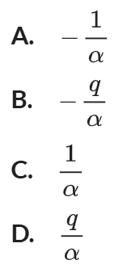
Let roots be $α, β,-1$
$$-αβ=-\frac{q}{q}=-1$$
$$αβ=1$$
$$∴β=\frac{1}{α}$$
C

- HSC Sample Question Extension 1 Band 5
The polynomial $P\left(x\right)=x^{3}+px^{2}+qx+r$ has roots $\sqrt{k}, -\sqrt{k}$, and $α$.
  - Show that $α+p=0$.

Using sum of roots $\sqrt{k}-\sqrt{k}=-$ $\frac{b}{a}$
$$a=-p$$
$$α+p=0$$
  - Show that $kα=r.$

Using product of roots: $α\sqrt{k}\left(-\sqrt{k}\right)=-$ $\frac{d}{a}$
$$-kα=-r$$
$$kα=r$$
  - Show that $pq=r$.
Using product of pairs of roots: $\sqrt{k}\left(-\sqrt{k}\right)+α\sqrt{k}-a\sqrt{k}=$ $\frac{c}{d}$
$$-k=q$$
Substitute into part b
$$-qα=r$$
Using $-α=p$ from part a
$$qp=r$$
- 2006 HSC Extension 1 Band 5
$P\left(x\right)=x^{3}+rx^{2}+sx+t$ has three real zeroes $1, α$, and $-α$
  - Find the value of $r$.

Use sum of roots. $r=-1$
  - Find the value of $s+t$.

Using $r=-1$ and $P\left(1\right)=0$
$$1-1+s+t=0$$
$$∴s+t=0$$
- If one root of the equation $x^{3}-bx^{2}+cx-d=0$ is equal to the product of the other two, show that ${\left(c+d\right)}^{2}=d{\left(b+a\right)}^{2}$, where $a=1$.
Let zeroes be $α, β, αβ$
Sum of roots: $α+β+αβ=b$
Sum of product of pairs of roots: $αβ+αβ^{2}+α^{2}β=c$
$αβ\left(1+β+α\right)=c$
Product of roots: $α^{2}β^{2}=d$
LHS = ${\left(c+d\right)}^{2}$
$=c^{2}+2cd+d^{2}$
$=α^{2}β^{2}{\left(1+β+α\right)}^{2}+2α^{3}β^{3}\left(1+β+α\right)+α^{4}β^{4}$
$=α^{2}β^{2}\left[{\left(1+β+α\right)}^{2}+2αβ\left(1+β+α\right)+α^{2}β^{2}\right]$
recognise perfect square
$=α^{2}β^{2}{\left(\left(1+α+β\right)+αβ\right)}^{2}$
$=d{\left(a+b\right)}^{2}$ as required.

- The cubic equation $x^{3}-Ax^{2}+3A=0$, where $A>0$, has roots $α, β,$ and $α+β$.
Show that $A=2\sqrt{6}$.
Sum of roots: $2α+2β=A$ (1)
Sum of product of pairs of roots: $αβ+β\left(α+β\right)+α\left(α+β\right)=0$ (2)
Product of roots: $αβ\left(α+β\right)=-3A$ (3)
Rearrange (1): $α+β=$ $\frac{A}{2}$, sub into (2)
$$αβ+β\left(\frac{A}{2}\right)+α\left(\frac{A}{2}\right)=0$$
$$αβ+\frac{A}{2}\left(α+β\right)=0$$
$$αβ+\frac{A^{2}}{4}=0$$
$$αβ=-\frac{A^{2}}{4}$$
Sub value of $α+β$ and $αβ$ into (3)
$$-\frac{A^{2}}{4}\left(\frac{A}{2}\right)=-3A$$
$$-\frac{A^{3}}{8}=-3A$$
$$A^{2}=24$$
$$A=\sqrt{24}$$
$$A=2\sqrt{6}$$

Sum and Product of Roots (Quartic)

- Sums and Products of Zeroes (Quartic)
For a quartic $P\left(x\right)=ax^{4}+bx^{3}+cx^{2}+dx+e$:
$$α+β+γ+δ=-\frac{b}{a} \\ αβ+αγ+αδ+βγ+βδ+γδ=\frac{c}{a} \\ αβγ+αβδ+αγδ+βγδ=-\frac{d}{a} \\ αβγδ=\frac{e}{a}$$
All methods in the previous sections apply.

Foundation
- For each quartic equation, where $α, β, γ, δ$ are roots of the equation, find:
- $x^{4}+2x^{3}-x^{2}-x+5=0$  $$α+β+γ+δ$$  $$-2$$  $$αβ+αγ+αδ+βγ+βδ+γδ$$  $$-1$$  $$αβγ+αβδ+αγδ+βγδ$$  $$1$$  $$αβγδ$$  $$5$$ | - $2x^{4}-2x^{3}-4x^{2}+3x-2=0$  $$α+β+γ+δ$$  $$1$$  $$αβ+αγ+αδ+βγ+βδ+γδ$$  $$-2$$  $$αβγ+αβδ+αγδ+βγδ$$  $$-\frac{3}{2}$$  $$αβγδ$$  $$-1$$ | - $2x^{4}-12x^{3}+7=0$  $$α+β+γ+δ$$  $$6$$  $$αβ+αγ+αδ+βγ+βδ+γδ$$  0  $$αβγ+αβδ+αγδ+βγδ$$  0  $$αβγδ$$  $$\frac{7}{2}$$

- If $α, β, γ, δ$ are the roots of $x^{4}-2x^{3}+5x-3=0$, find:
- $αβγδ$  $$-3$$ | - $αβγ+αβδ+αγδ+βγδ$  $$-5$$ | - $\frac{1}{α}$ + $\frac{1}{β}$ + $\frac{1}{γ}$ + $\frac{1}{δ}$  $$\frac{5}{3}$$

Development
- If $α, β, γ,$ and $δ$ are the roots of $x^{4}-5x^{3}+2x^{2}-4x-3=0$, find:
- $α+β+γ+δ$  5 | - $αβ+αγ+αδ+βγ+βδ+γδ$  2
- $αβγ+αβδ+αγδ+βγδ$  4 | - $αβγδ$  $$-3$$
- $\frac{1}{α}$ + $\frac{1}{β}$ + $\frac{1}{γ}$ + $\frac{1}{δ}$  $$-\frac{4}{3}$$ | - $\frac{1}{αβ}$ + $\frac{1}{αγ}$ + $\frac{1}{αδ}$ + $\frac{1}{βγ}$ + $\frac{1}{βδ}$ + $\frac{1}{γδ}$  $$-\frac{2}{3}$$
- $\frac{1}{αβγ}$ + $\frac{1}{αβδ}$ + $\frac{1}{αγδ}$ + $\frac{1}{βγδ}$  $$-\frac{5}{3}$$ | - $α^{2}+β^{2}+γ^{2}+δ^{2}$  21

  - Show that 1 is a zero of the polynomial $P\left(x\right)=x^{4}-2x^{3}+7x-6$.

$$P\left(1\right)=1-2+7-6=0$$
  - If $α, β, γ$ are the 3 other zeroes, find the value of $α+β+γ$ and $αβγ$

$$α+β+γ=1, αβγ=-6$$
- The polynomial equation $x^{4}+ax^{3}+bx^{2}+cx+d=0$ has roots $α, β, γ, δ$.
  - Show that $α^{2}+β^{2}+γ^{2}+δ^{2}=a^{2}-2b$.

$$α^{2}+β^{2}+γ^{2}+δ^{2}={\left(α+β+γ+δ\right)}^{2}-2\left(αβ+αγ+αδ+βγ+βδ+γδ\right)$$
$={(-a)}^{2}-2b=a^{2}-2b$ as required
  - Hence, show that $x^{4}-3x^{3}+5x^{2}+4x-1=0$ cannot have four real roots.

$$α^{2}+β^{2}+γ^{2}+δ^{2}=a^{2}-2b=9-10=-1<0$$
Since the sum of squares of roots is negative, there is at least 1 non-real root.
Since a quartic has 4 roots, not all 4 roots are real.

Mastery
- The polynomial equation $x^{4}+px^{3}+qx^{2}+rx+s=0$ has two roots that sum to zero, and another two roots being reciprocals of each other. Show that:
- $q=1+s$  $$α, -α, β,\frac{1}{β} are the roots.$$  $$Product of roots: -α^{2}=s$$  $$Sum of product of pairs of roots: -α^{2}+αβ+\frac{α}{β}-αβ-\frac{α}{β}+1=q$$  $$∴-α^{2}+1=q$$  $$∴s+1=q$$ | - $r=ps$  Sum of roots: $β+$ $\frac{1}{β}$ $=-p$  Sum of product of 3 roots: $-α^{2}β-$ $\frac{α^{2}}{β}$ $-α+α=r$  $-α^{2}β-$ $\frac{α^{2}}{β}$ $=r$  $$-α^{2}\left(β+\frac{1}{β}\right)=r$$  $$-s\left(-p\right)=r$$  $sp=r$ as required.

- If $x=2$is a double root of $ax^{4}-2x^{3}-8x+16=0$, find the value of $a$ and the sum of the other two roots.

$$P\left(2\right)=16a-16-16+16=0$$
$$∴a=1$$
Let roots be $2, 2, α,β$
Sum of roots $4+α+β=$ $\frac{2}{a}$
$$4+α+β=2$$
$$∴α+β=-2$$
- Show that $x=1$ and $x=-2$ are zeroes of $P\left(x\right)$, then find the other two zeroes using sum and product of roots.
- $x^{4}+3x^{3}-3x^{2}-7x+6$  $$P\left(1\right)=3-5-10+20-8=0$$  $$P\left(-2\right)=3{\left(-2\right)}^{4}-5{\left(-2\right)}^{3}-10{\left(-2\right)}^{2}+20\left(-2\right)-8=0$$  Sum of roots: $α+β-2+1=-3$  $$α+β=-2$$  Product of roots: $-2αβ=6$  $$αβ=-3$$  Solving simultaneously,  $$α\left(-2-α\right)=-3$$  $$α^{2}+2α-3=0$$  $$\left(α+3\right)\left(α-1\right)=0$$  $$α=-3, 1$$  If $α=-3, β=1,$if $α=1, β=-3$ (these are the same)  $∴$other zeroes are −3, 1, so 1 is a double root. | - $P\left(x\right)=3x^{4}-5x^{3}-10x^{2}+20x-8$  $$P\left(1\right)=1+3-3-7+6=0$$  $$P\left(-2\right)={\left(-2\right)}^{4}+3{\left(-2\right)}^{3}-3{\left(-2\right)}^{2}-7\left(-2\right)+6=0$$  Sum of roots: $α+β-2+1=$ $\frac{5}{3}$  $$α+β=\frac{8}{3}$$  Product of roots: $-2αβ=-$ $\frac{8}{3}$  $$αβ=\frac{4}{3}$$  Solving simultaneously,  $$α\left(\frac{8}{3}-α\right)=\frac{4}{3}$$  $$3α^{2}-8α+4=0$$  $$\left(3α-2\right)\left(α-2\right)=0$$  $$α=\frac{2}{3}, 2$$  If $α=\frac{2}{3}, β=\frac{6}{3}=2$, if $α=2, β=$ $\frac{2}{3}$ (these are the same)  $∴$ other zeroes are $\frac{2}{3}$ $, 2$

- Find the zeroes of $x^{4}-3x^{3}-8x^{2}+12x+16$ if they are $α, 2α, β, and 2β$.

Sum of roots: $3α+3β=3$
$$α+β=1$$
Product of roots: $4α^{2}β^{2}=16$
$$α^{2}β^{2}=4$$
Solving simultaneously,
$$α^{2}{\left(1-α\right)}^{2}=4$$
$$α\left(1-α\right)=±2$$
Consider 2 cases:
$α\left(1-α\right)=2$ $α\left(1-α\right)=-2$
$α^{2}-α+2=0$ $α^{2}-α-2=0$
No solution as $Δ<0$ $\left(α+1\right)\left(α-2\right)=0$
$$∴α=-1,2$$
If $α=-1$, $β=2$, If $α=2, β=-1$, (these are the same)
$∴$ −1, −2, 2 and 4

- The polynomial $P\left(x\right)=x^{4}+ax^{3}+bx^{2}+cx+d$ has two zeroes that are opposites and two zeroes that are reciprocals. Show that $b=1+d$ and $c=ad$.

$$Let roots be α, -α, β, \frac{1}{β}$$
$$Sum of roots: β+\frac{1}{β}=-a \left(1\right)$$
$$Sum of products 2 at a time: -α^{2}+αβ+\frac{α}{β}-αβ-\frac{α}{β}+1=b \\ ∴-α^{2}+1=b \left(2\right)$$
$$Sum of products 3 at a time: -α^{2}β-\frac{α^{2}}{β}+r-r=-c \\ ∴-α^{2}\left(β-\frac{1}{β}\right)=-c \left(3\right)$$
$$Product of roots: -α^{2}=d \left(4\right)$$

$$sub \left(4\right) into \left(2\right)→d+1=b$$

$$sub \left(1\right) and \left(4\right) into \left(3\right)→d\left(-a\right)=-c \\ -ad=-c \\ c=ad$$

Applications of Polynomials to Geometry Problems

- Applications of Polynomials to Geometry Problems
Find the points where two curves meet by setting their equations equal and solving for $x$.
- Each zero represents a point where curves intersect.
- No zeroes mean no intersections exist.
- Single roots show where curves pass through each other.
- Double roots indicate curves are tangent at that point (they touch and bounce away).
Sketch using DESMOS to visualise what's happening.

- Guided Practice
Find the points of intersection of a cubic and a line.
Consider $y=4-x$ and $y=x^{3}-5x^{2}+6x+1$.
- Equate the two curves to find an equation that can be used to find the points of intersection.

- Find two roots using factor theorem, then use sum of roots to find the third root.

- Hence explain why the line is tangent to the cubic, and state the points of intersection.
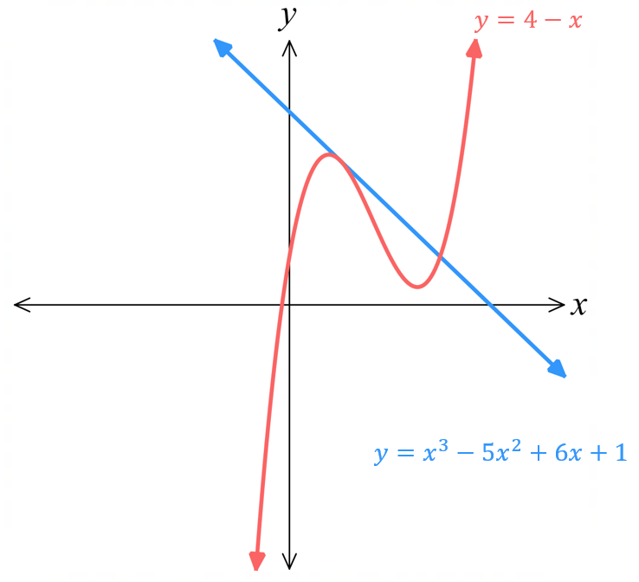

- Horizontal Distance between Zeroes
To find horizontal distance $|α-β|$ between two intersection points, use this identity:
$${\left(α-β\right)}^{2}={\left(α+β\right)}^{2}-4αβ \\ \sqrt{} \sqrt{} \\ \left|α-β\right|=\sqrt{{\left(α+β\right)}^{2}-4αβ}$$

- Guided Practice
The line $y=2x-2$ meets the cubic $y=x^{3}-5x^{2}+4x$ at $F\left(1,0\right)$ and also at points $A$ and $B$.
- Show that the $x$ coordinates of $α$ and $β$ satisfy $x^{3}+5x^{2}+2x+2=0$.
- Find $α+β$.
- Hence find the coordinates of the midpoint $M$ of $AB$.
- Show that $αβ=-2$.
- Use the identity ${\left(α-β\right)}^{2}={\left(α+β\right)}^{2}-4αβ$ to show that horizontal distance $\left|α-β\right|$ between $A$ and $B$ is $2\sqrt{6}$.
- Hence find the exact length of $AB$using the horizontal distance and the gradient.
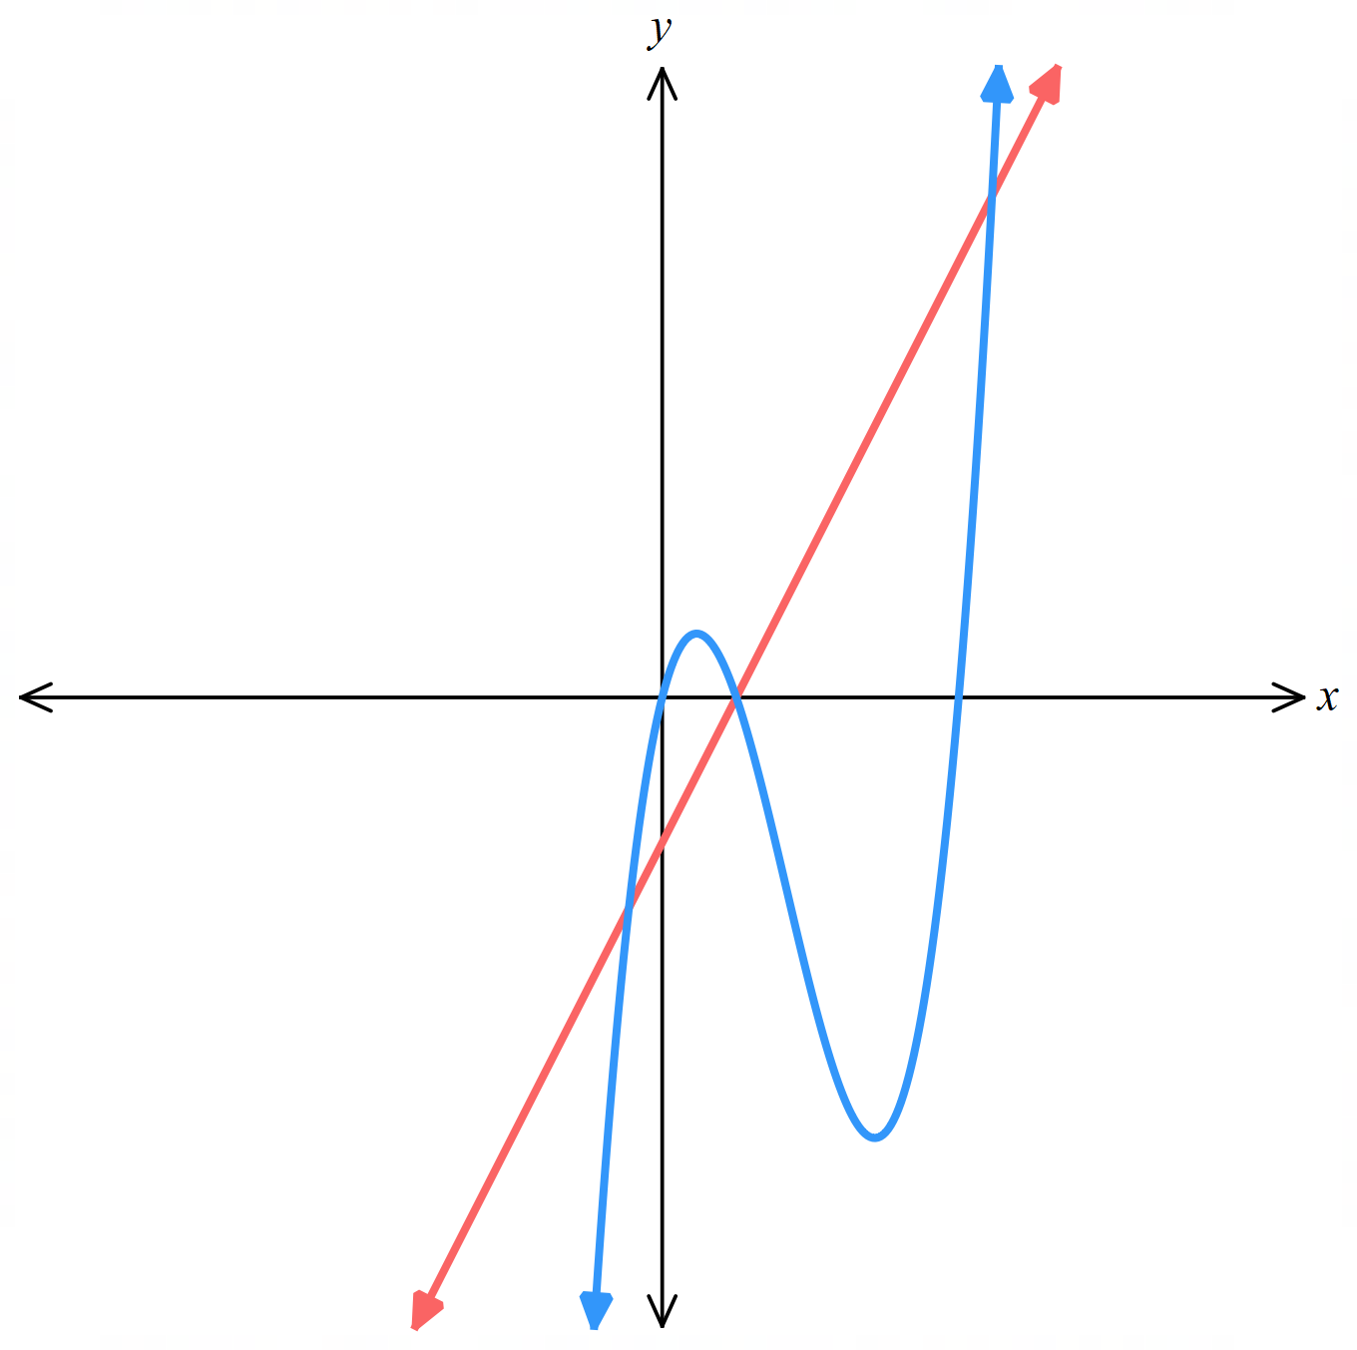

Foundation
- Consider the parabola $y=x^{2}-6x$ and the line $y=2x-16$.
  - Show that the $x$-coordinates of the points of intersection satisfy the equation
$x^{2}-8x+16=0$.

$$x^{2}-6x=2x-16$$
$$∴x^{2}-8x+16=0$$
  - By factorising the LHS of the equation, show that the line is tangent to the parabola, and state hence find the tangent point.

$$x^{2}-8x+16=0$$
$${\left(x-4\right)}^{2}=0$$
4 is a double root, so the line is tangent to the parabola at $x=4$.
Tangent point is $\left(4, -8\right)$
  - Use DESMOS to visualise what is happening by sketching $y=x^{2}-6x$ and $y=2x-16$.

- Consider the line $y=-2x+k$ and the parabola $y=x^{2}-6x$.
  - Show that the $x$-coordinates of the points of intersection satisfy the equation
$x^{2}-4x-k=0$.

$$-2x+k=x^{2}-6x$$
$$∴x^{2}-4x-k=0$$
  - Suppose that the line is a tangent to the parabola; in other words, the two roots of the quadratic equation are equal. Let the roots be $α$ and $α$.
    - Using sum of roots, show that $α=2$.
$$α+α=-\frac{b}{a}$$
$$2α=4$$
$$α=2$$
    - Using product of roots, show that $α^{2}=-k$ and hence find $k$.
$$α×α=\frac{c}{a}$$
$$α^{2}=-k$$
$$2^{2}=-k$$
$$k=-4$$
    - Therefore, state the equation of the tangent line and find its point of contact with the parabola.
Tangent line: $y=-2x-4$
Point of intersection: $x^{2}-4x+4=0$
$${\left(x-2\right)}^{2}=0$$
$$x=2$$
$$y=-2\left(2\right)-4=-8$$
Tangent point at $\left(2,-8\right)$
  - Use DESMOS to visualise what is happening by sketching $y=-2x-4$ and $y=x^{2}-6x$.

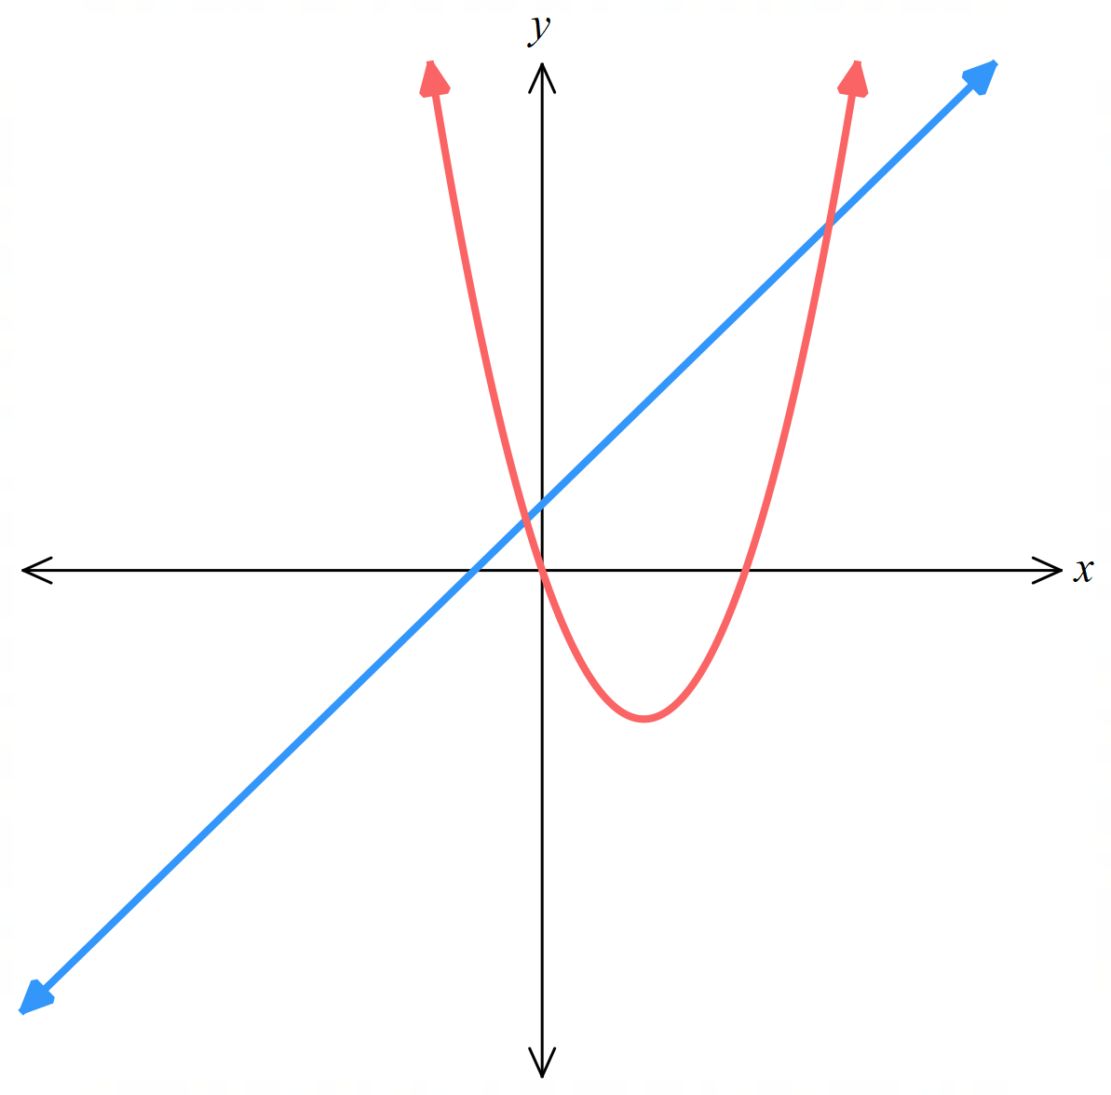
- The line $y=x+1$ meets the parabola at $y=x^{2}-3x$ at points $A$ and $B$.
A sketch has been provided.
  - Show that the $x$-coordinates $α$ and $β$ of $A$ and $B$
satisfy $x^{2}-4x-1=0.$

$$x+1=x^{2}-3x$$
$$x^{2}-4x-1=0$$
  - Find $α+β$, and hence find the coordinates of the midpoint $M$ of $AB$.
$$x=\frac{4±\sqrt{{\left(-4\right)}^{2}-4\left(1\right)\left(-1\right)}}{2}$$
$$x=\frac{4±\sqrt{20}}{2}$$
$$=\frac{4±2\sqrt{5}}{2}$$
$$=2±\sqrt{5}$$
$$α=2+\sqrt{5}, β=2-\sqrt{5}$$
Midpoint of $x$ coordinates is $\frac{2+\sqrt{5}+2-\sqrt{5}}{2}=2$
Substitute into equation of the line (NOT the parabola): $y=2+1=3$
$$∴\left(2,3\right)$$
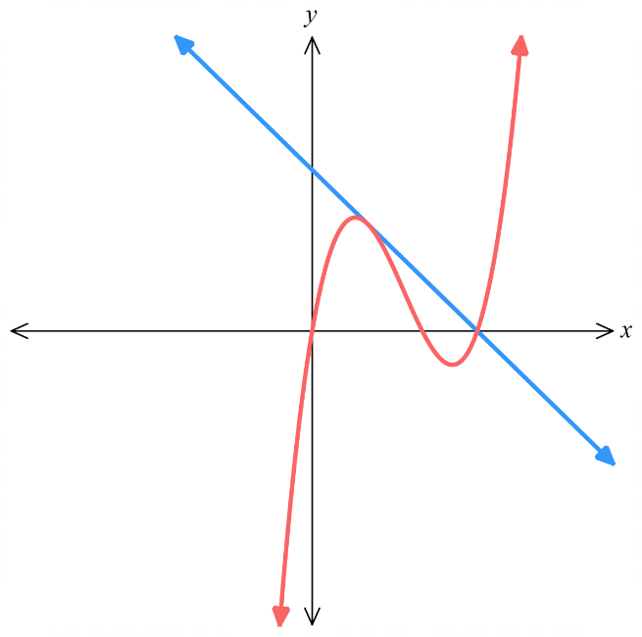
- Consider the line $y=3-x$ and the cubic $y=x^{3}-5x^{2}+6x$.
A sketch has been provided.
  - Show that the $x$-coordinates of the points of intersection
satisfy $x^{3}-5x^{2}+7x-3=0$.

$$3-x=x^{3}-5x^{2}+6x$$
$$∴x^{3}-5x^{2}+7x-3=0$$
  - Show that $x=1$ and $x=3$ are zeroes of the equation, and hence use the sum of zeroes to find the third root.
$$P\left(1\right)=0$$
$$P\left(3\right)=0$$
Let third root be $α$
$$1+3+α=5$$
$$α=1$$
  - Explain why the line is tangent to the cubic, then find the points of intersection.

1 is a double root, so the line is tangent to the parabola at $x=1$
Points of intersections are $\left(1,2\right)$ and $\left(3, 0\right)$

Development

  - Show that the $x$-coordinates of the points of intersection of the line $y=mx$ and the cubic
$y=x^{3}-5x^{2}+6x$ satisfy the equation $x^{3}-5x^{2}+\left(6-m\right)x=0$

$$mx=x^{3}-5x^{2}+6x$$
$$x^{3}-5x^{2}+6x-mx=0$$
$$x^{3}-5x^{2}+\left(6-m\right)x=0$$
  - Explain why one of the points of intersection is at $x=0$.
$$P\left(0\right)=0$$
Alternatively, you can factor out $x\left(x^{2}-5x+6-m\right)=0$
$∴$ by null factor law, $x=0$ is a zero.
  - Suppose that the line is tangent to the cubic at a point other than the origin, so that the roots of the equation are $0, α, α$.
    - Using sum of roots, show that $α=$ $\frac{5}{2}$
$$2α=5$$
$$α=\frac{5}{2}$$
    - Using the product of pairs of roots, show that $α^{2}=6-m$, and hence find $m$.

$$0+0+α^{2}=6-m$$
$$α^{2}=6-m$$
$$m=6-α^{2}$$
$$=6-{\left(\frac{5}{2}\right)}^{2}$$
$$=-\frac{1}{4}$$
    - Find the equation of the tangent and its point of contact $T$.

Equation of tangent: $y=-$ $\frac{x}{4}$
Point of contact at $x=$ $\frac{5}{2}$, $y=-$ $\frac{\left(\frac{5}{2}\right)}{4}$ $=-$ $\frac{5}{8}$
$$\left(\frac{5}{2}, -\frac{5}{8}\right)$$
  - Use DESMOS to visualise what is happening by sketching the line and the cubic.

- The line $y=x-2$ meets the cubic $x^{3}-5x^{2}+6x$ at $F\left(2,0\right)$ and also at $A$ and $B$.
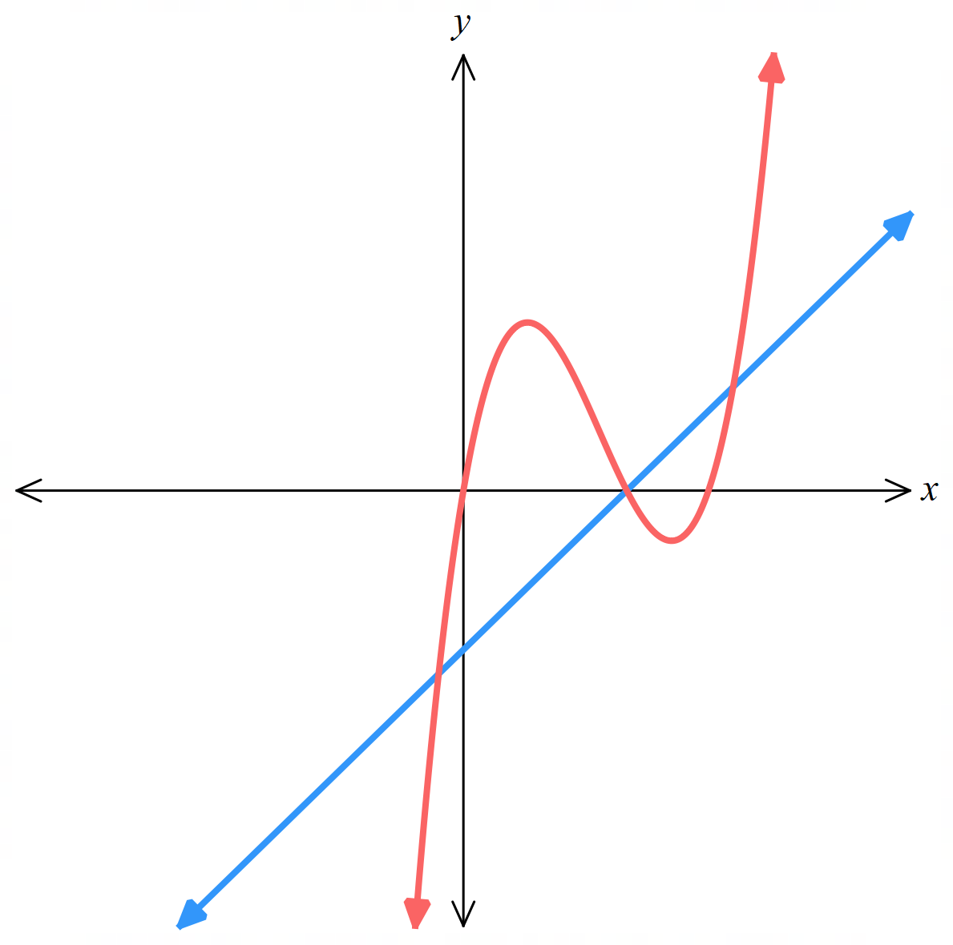
  - Show that the $x$-coordinates $α$ and $β$ of $A$ and $B$
satisfy $x^{3}-5x^{2}+5x+2=0$

$$x^{3}-5x^{2}+6x=x-2$$
$$∴x^{3}-5x^{2}+5x+2=0$$
  - Find $α+β$.
Using sum of roots,
$$α+β+2=5$$
$$α+β=3$$
  - Hence the coordinates of the midpoint $M$ of $AB$.
Averaging the $x$-coordinates of $A$ and $B$ will find the $x$-coordinate of the midpoint; substitute this into the equation of the line to find:
$$\left(\frac{3}{2},-\frac{1}{2}\right)$$
  - Show that $αβ=-1$
Using product of roots,
$$2αβ=-2$$
$$αβ=-1$$
  - Use the identity ${\left(α-β\right)}^{2}={\left(α+β\right)}^{2}-4αβ$ to show that the horizontal distance $\left|α-β\right|$ between $A$ and $B$ is $\sqrt{13}$.

$${\left(α-β\right)}^{2}={\left(3\right)}^{2}-4\left(-1\right)=13$$
$$∴\left|α-β\right|=\sqrt{13}$$
  - Hence find the length of $AB$.
The line has gradient 1, so if the horizontal distance is $\sqrt{13}$, the vertical distance is also $\sqrt{13}$.
Alternatively, you could find $y$-coordinates of the points of intersection by substituting $x$-values into the equation of the line.
$$AB=\sqrt{{\left(\sqrt{13}\right)}^{2}+{\left(\sqrt{13}\right)}^{2}}$$
$$AB=\sqrt{26}$$

